MODULE-2 (Web Development)

B1. Create a web page that shows a message “This is my first HTMLpage”.

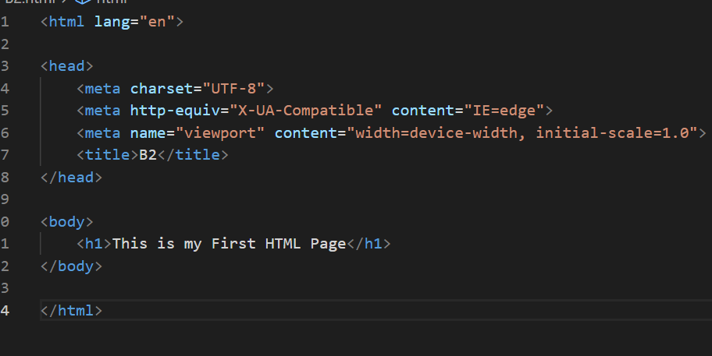

B2. Create Registration Form of bank Using HTML and CSS

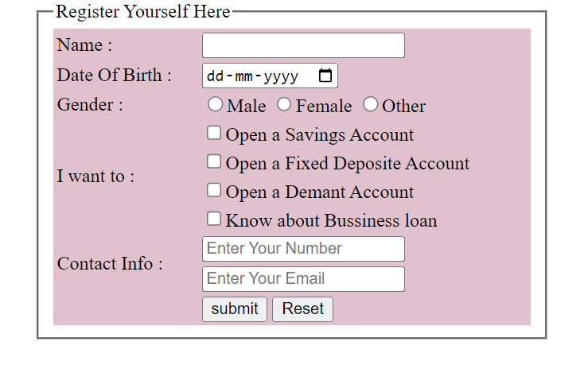

B3. How to specify the column properties of each column within a colgroup element?

-The <colgroup> tag is used to give styling or to define property in a table for each column.

-Use <col> tag in a <colgroup> tag to select column.

-Use span attribute to define the number of columns on which the property will be applied.

B4.How to define a container for an external(non-HTML)application?

-Use the <embed> tag in HTML, represent a container for external application.

B5. How to define an option in a drop-downlist?

<select>Known Languages

    <option>Hindi</option>

    <option>English</option>

    <option>Gujrati</option>

</select>

B6. How to underline a text in an HTML document?

-by using <u> tag

-by using css use property text-decoration and value underline

(text-decoration: underline;)

Intermediate

1.Create Tabular Layout using HTML and CSS.

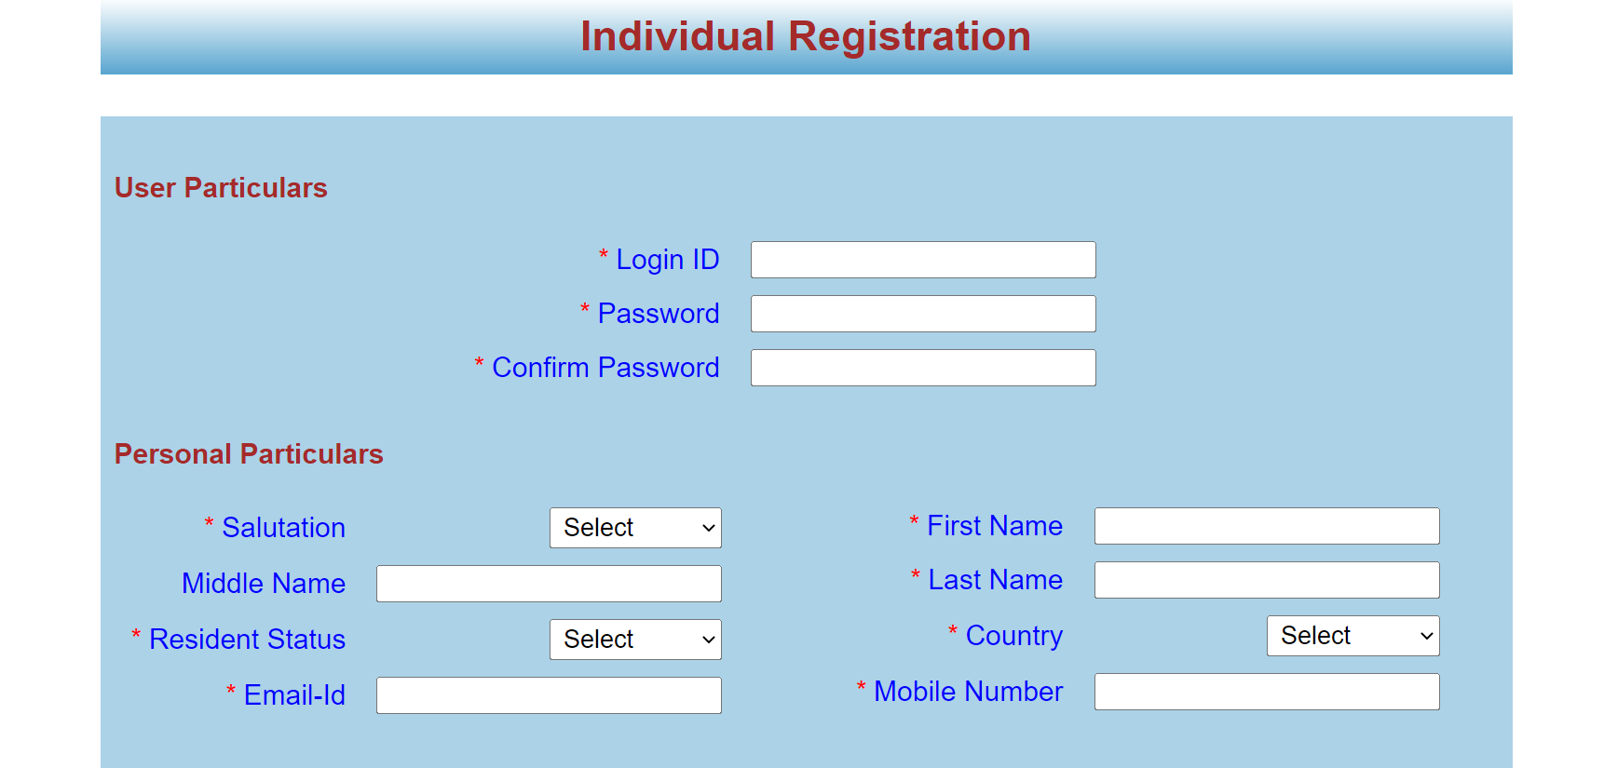

2. Create elastic Page Layout.



3. Create simple website template using HTML and CSS it contains: Header, Main Content and Footer

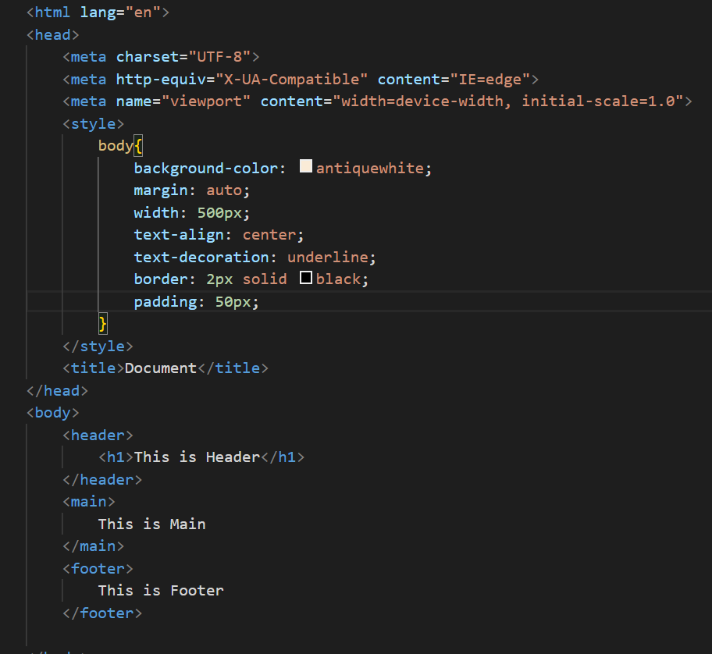

4. Create simple three pages using External CSS, Internal CSS, Inline CSS.

-Inline CSS

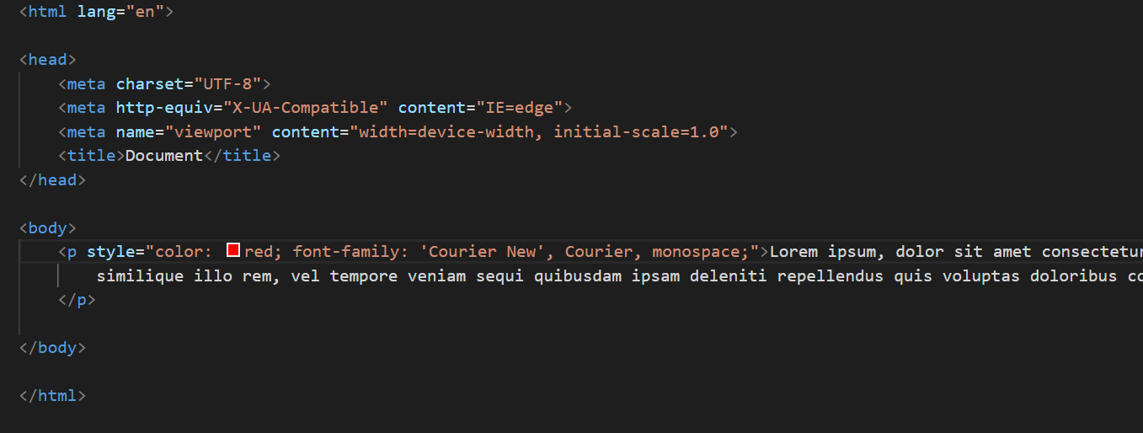

-Internal CSS

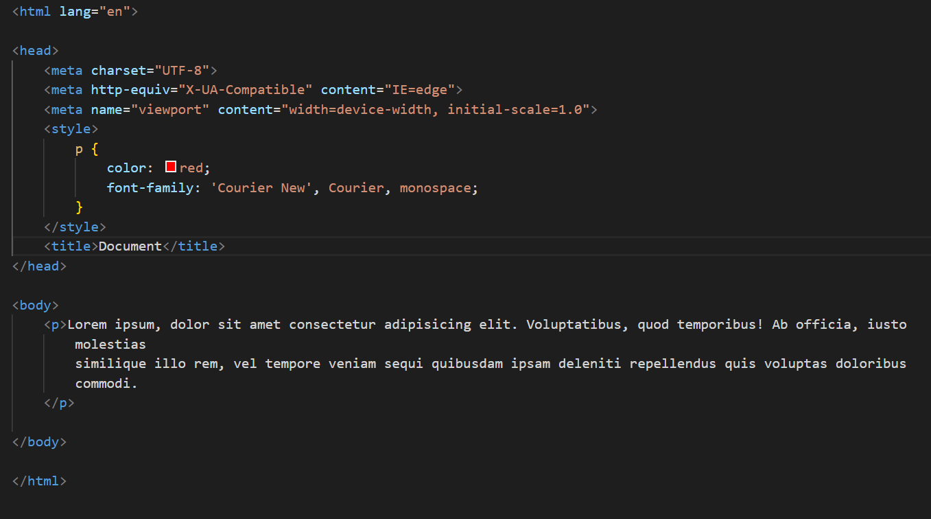

-External CSS

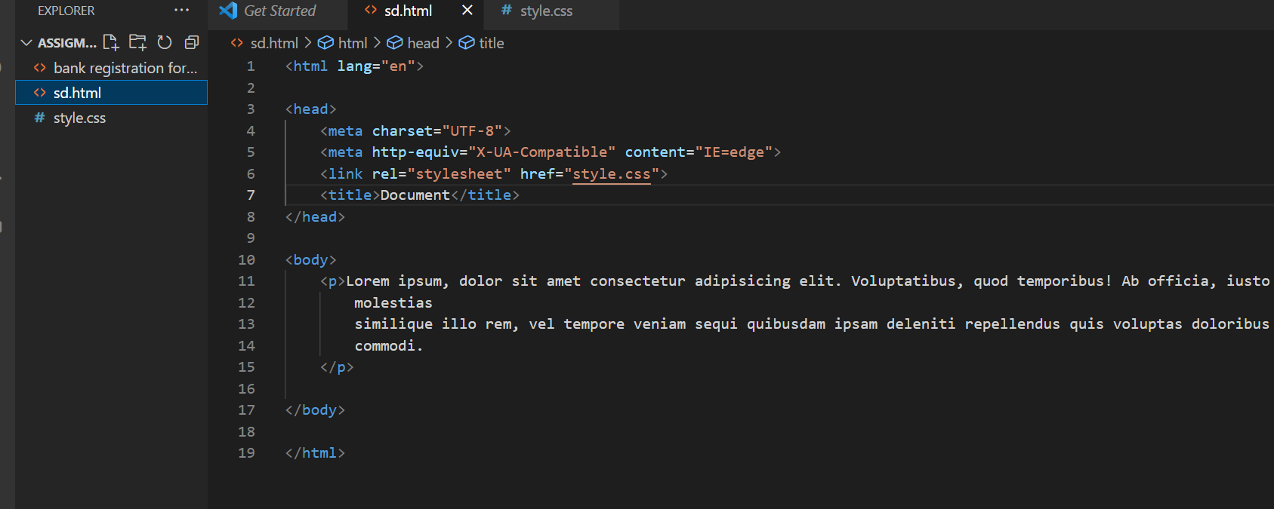

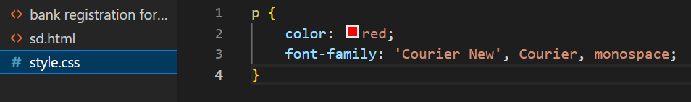

5. In how many ways can a CSS be integrated as a webpage?

-There are three ways of integrating CSS in a webpage.

(1) Inline CSS (2) Internal CSS (3) External CSS

Advance

A1. Design below page like html page

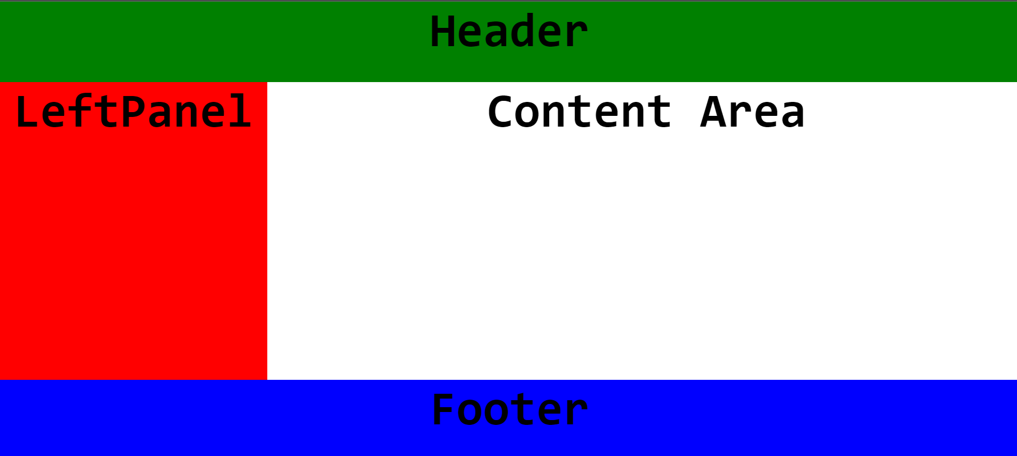

A2. Create a List Item on the topic Restaurant.

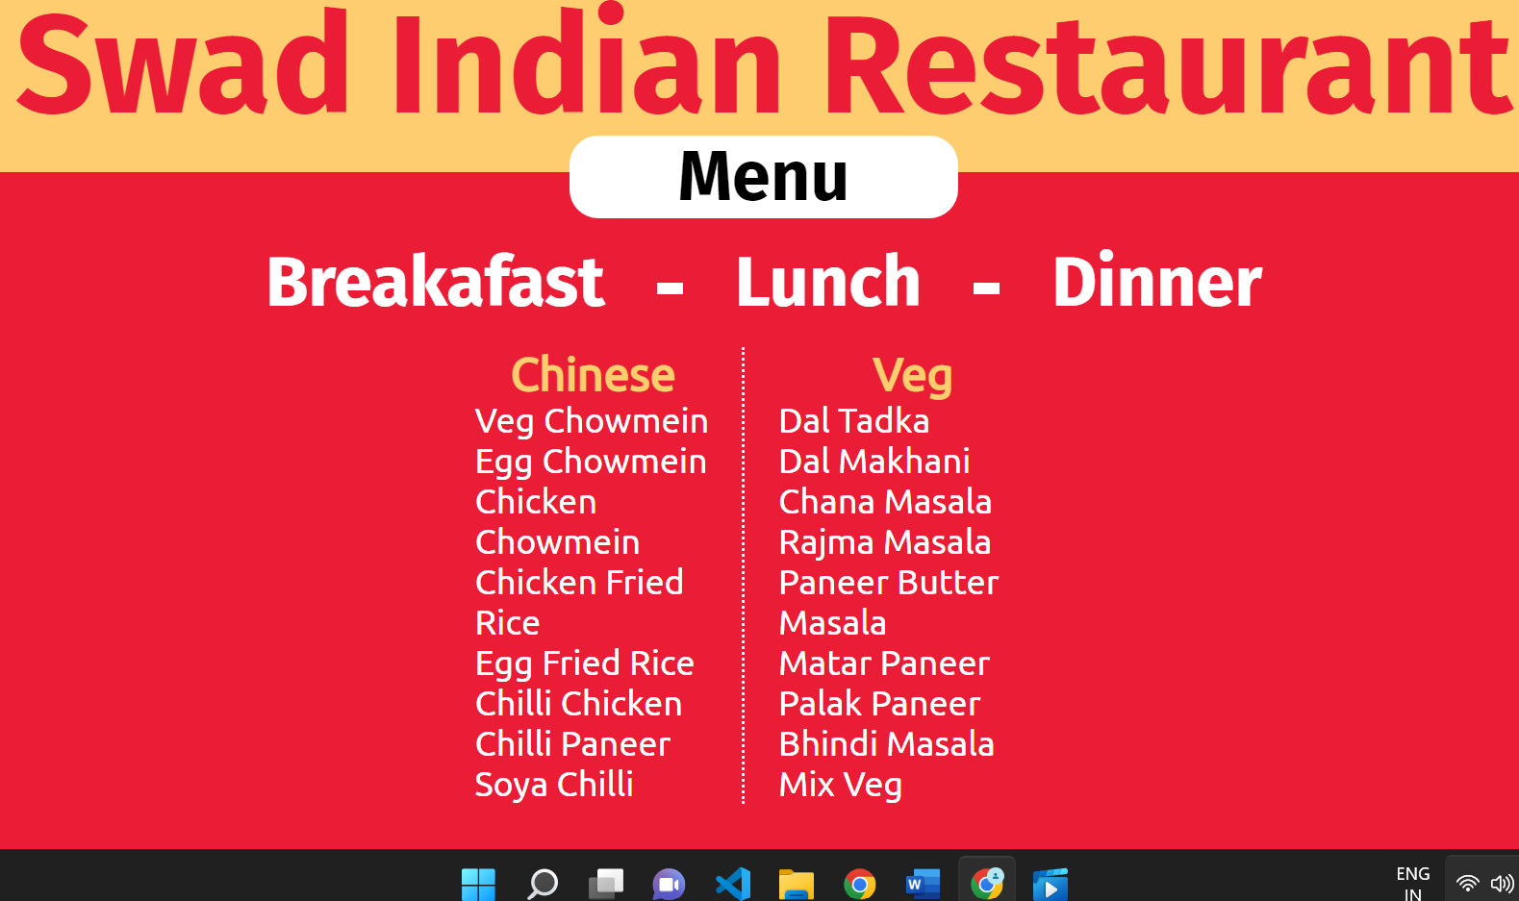

A3. Create a Table Of college Management system using row span & colspan.

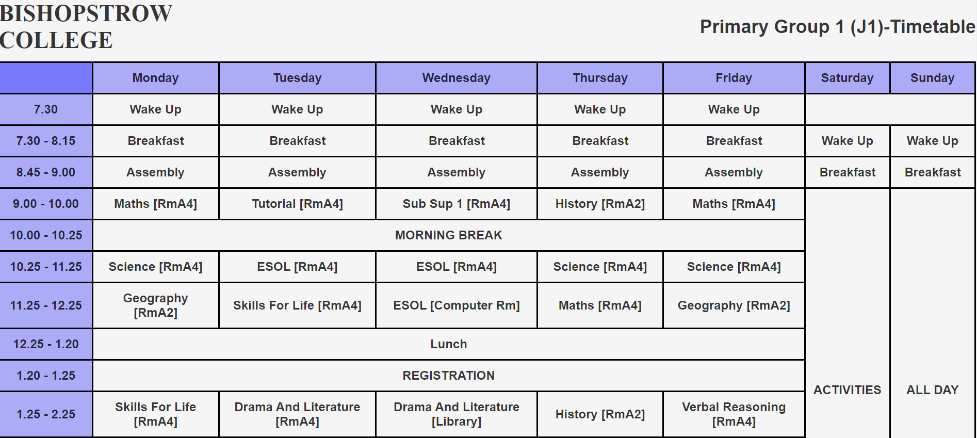

A4. Create link-pseudo classes using external css, to format links on the pages.

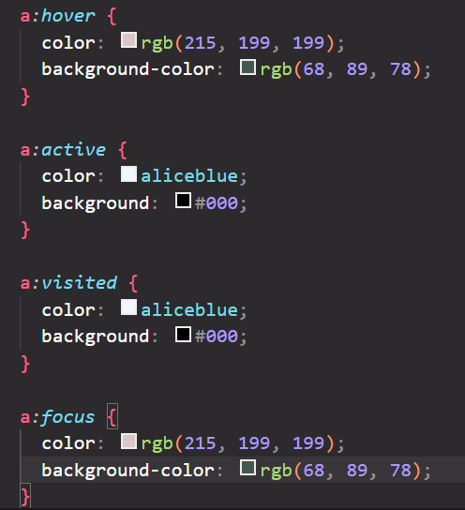

A5. Create a division which should not resize on browser resize.

-Look at html file non-resizable-div.html.

A6. Create one Page Layout

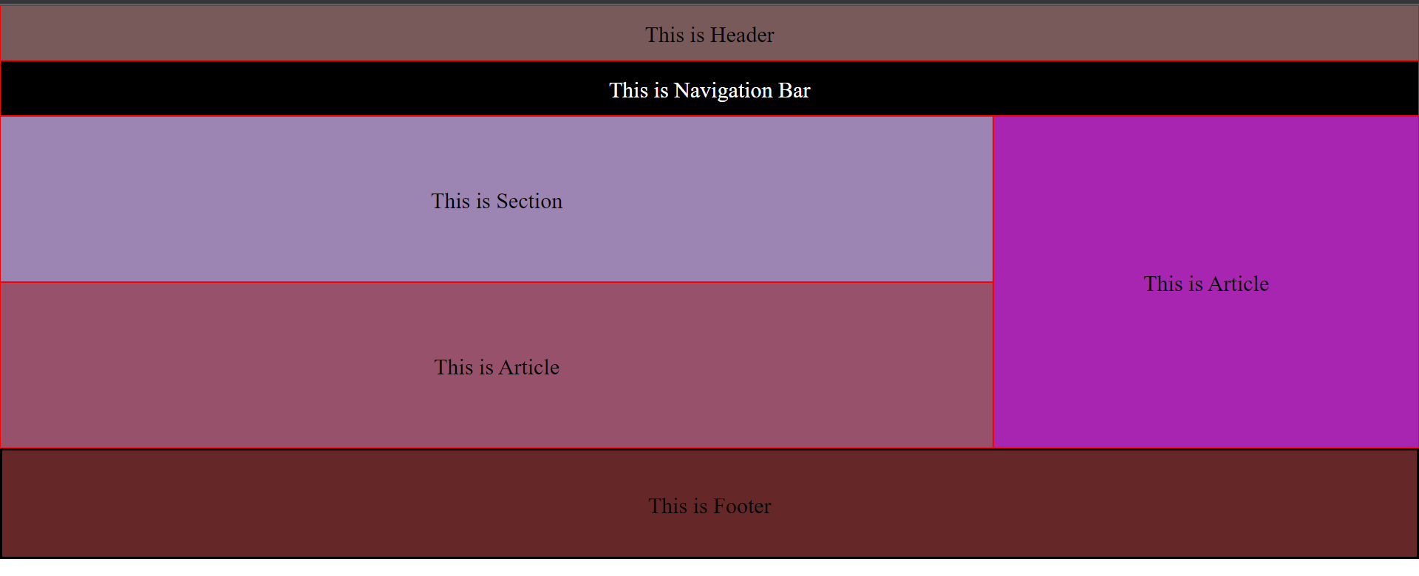

A8. What is the usage of Class selector?

-Class selectors are used in CSS to select elements which belongs to same class attribute.

-To select the elements with the class attribute use (.) character before the class name.

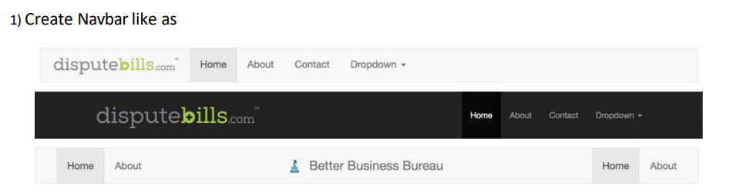







2) Dropdown menu using ul li

